**Design and Implementation of a High-Efficiency 4th-Order Boost Converter**

*Submitted in partial fulfillment of the requirements for the degree of*

Bachelor of Technology

in

Electrical and Electronics Engineering

*by*

**Awdesh Fernando E (21BEE0304) Parvesh Mohamad (21BEE0307) Preethem S Babu (21BEE0274) Under the guidance of**

**Dr. ARUNKUMAR G**

**School of Electrical Engineering VIT,Vellore.**



November,2024

**DECLARATION**

I here by declare that the thesis entitled “**Design and Implementation of a High- Efficiency 4th-Order Boost Converter**” submitted by me, for the award of the degree of *Bachelor of Technology in Electrical and Electronics Engineering* to VIT University is a record of Bonafide work carried out by me under the supervision of **Dr. Arunkumar G**, Associate Professor Sr, School of Electrical Engineering, VIT University, Vellore.

I further declare that the work reported in this thesis has not been submitted and will not be submitted, either in part or in full, for the award of any other degree or diploma in this institute or any other institute or university.

Place: Vellore

Date: 10/11/2024

**Signature of the Candidate**

**CERTIFICATE**

This is to certify that the thesis entitled “**Design and Implementation of a High- Efficiency 4th-Order Boost Converter**” submitted by **Awdesh Fernando E(21BEE0304)**, School of Electrical Engineering (SELECT), VIT, Vellore, for the award of the degree of *Bachelor of Technology in Electrical and Electronics Engineering,* is a record of bonafide work carried out byhim under my supervision during the period 15/07/2024 to 13/11/2024 as per the VIT code of academic and research ethics.

The contents of this report have not been submitted and will not be submitted either in part or in full, for the award of any other degree or diploma in this institute or any other institute or university. The thesis fulfills the requirements and regulations of the University and in my opinion meets the necessary standards for submission.



**Signature of the Guide (Dr. Arunkumar G)**

Place: Vellore Date: 10/11/2024

**The thesis is satisfactory**

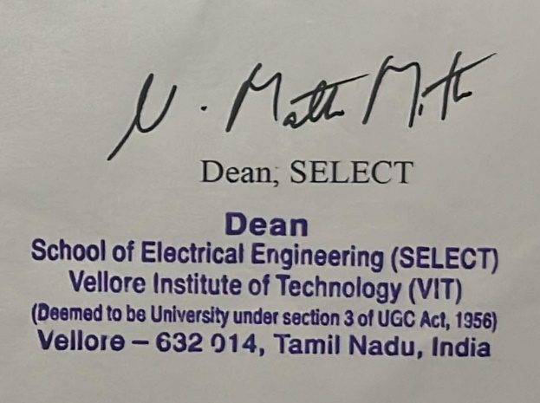

Approved by

Head of the Department

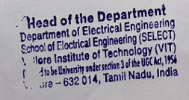EEE

**Acknowledgements**

With immense pleasure and deep sense of gratitude, I wish to express my sincere thanks to my supervisor **Dr. Arunkumar G**, Associate Professor Sr, School of Electrical Engineering (SELECT), VIT University, without his motivation and continuous encouragement, this project work would not have been successfully completed.

I am grateful to the Chancellor of VIT University, **Dr. G. Viswanathan**, the Vice Presidents, the Vice Chancellor for motivating me to carry out research in the VIT University and also for providing me with infrastructural facilities and many other resources needed for my project.

I express my sincere thanks to **Dr. Mathew M. Noel**, Dean, SELECT, VIT University for his kind words of support and encouragement. I like to acknowledge the support rendered by **my colleagues** in several ways throughout my project work.

I wish to extend my profound sense of gratitude to **my parents** for all the sac- rifices they made during my research and also providing me with moral support and encouragement whenever required.

Last but not the least, I would like to thank the research scholar **Mr. Pulipaka Srikanth** for their constant encouragement, moral supportand eternal guidance.

Place: Vellore

Date: 10/07/2024 **Awdesh Fernando E**

# Executive Summary

This project implements a Fourth Order Boost Converter for PV based Solar applications. It addresses the absence of detailed hardware analysis by im-plementing a working, low-power hardware prototype with detailed operational analysis and parameter documentation. The input to the converter was provided by the ChromaProgrammable DC Power Supply 62050H-600S, and the results were captured using the Keysight IntegraVision Power Analyzer PA2203A. The gate pulses for the MOS- FET switch was provided using the Analog Discovery. The simulation of the proposed converter was carried out on the PLECS software, and it is designed inthe boost mode, with an input of 36*V* and an output of 72. The detailed designsteps and considerations have also been duly mentioned in the concerned chapters. The measured efficiency during hardware validation has also been provided for better in- sights into the different types of losses that can occur during the prototyping stage. Theproject, thus, aims to further advance the Solar infrastructure through the unexplored, but powerful potential of the Fourth order Boost converter, and as a resultlead to sustainability and reduction in the carbon footprints.

**TABLE OF CONTENTS**

**Acknowledgement**. . . . . . . . . . . . . . . . . . . . . . . . . . . . . . . . . i

Executive Summary ii

List of Figures v

List of Tables vii

1. INTRODUCTION 1
   1. Background 1
   2. Motivation 2
   3. Objective 3
   4. Methodology 3
2. LITERATURE REVIEW 4
   1. Literature Review 4
   2. Research Gap 7
   3. Proposed Solution 8
3. OPERATION OF THE PROPOSED CONVERTER 9
   1. Mode 1 : Continuous Conduction Mode (CCM) 9
   2. Mode 2 : Discontinuous Conduction Mode (DCM) 10
   3. Mode 3 : Boundary Conduction Mode (BCM)… 10
   4. Mode 4 : Burst Mode (Light Load Mode) 11
4. DESIGN OF THE PROPOSED CONVERTER 16
   1. Voltage gain calculation and choice of switching frequency 16
   2. Selection of Magnetizing Inductance 13
   3. Calculation of Resonant Inductance 13
   4. Calculation of Resonant Capacitance 13
   5. Gain Curves 14
   6. Design Calculations 14
   7. Component Selection 14
5. RESULTS 16
   1. PLECS Simulation 16
   2. Experimental Setup 19
   3. Hardware Results 20
6. CONCLUSION AND FUTURE SCOPE 23
   1. Conclusion 23
   2. Future Scope 23
   3. References 24

**LIST OF FIGURES**

2.1 Circuit of the Proposed Converter 6

* 1. Mode 1 Operation 9
  2. Mode 2 Operation 10
  3. PLECS Simulation 16
  4. Waveforms of voltage and current on the (a) Source (b) Load 17
  5. Waveforms of voltage and current on the (a) Switch (b) Diode… 17
  6. Waveforms of voltage and current on the (a) Inductor L1 (b) Inductor L1 18
  7. Waveforms of voltage and current on the (a) Capacitor C1 (b) Capacitor C2 18
  8. Experimental Setup of the proposed fourth order boost converter 19
  9. Efficiency of the proposed converter as recorded on the oscilloscope 20
  10. Waveforms of voltage, current, power for input and output s ide of the

proposed circuit 20

**LIST OF TABLES**

4.1 Design Specifications of the Proposed Fourth Order Boost Converter 15

**CHAPTER 1**

**INTRODUCTION**

The PV grid connected generating system (PVGCS) is recently becoming a fast growing research area in the residential applications [1]. The output voltage of the PV arrays is relatively low. To meet existing distribution voltage levels, the PV series- connected (PVSC) configuration is the conventional solution [2]. In the residential PVGCS, the PV arrays are usually installed on the roof. Thus, the generated power of the PV module (PVM) is reduced greatly with PVSC configuration, when they are covered by the shadows, trees, etc. In these situations, the PV parallel-connected (PVPC) configuration is more efficient than the PVSC configuration due to superior PV performance [1]–[3]. On the other hand, only a low voltage is generated with the PVPC configuration, which makes it easy to satisfy the safety requirements. The PV panel has a low voltage characteristic where its output voltage typically ranges from 20 V to 50 V. In order to integrate the PV supply to utility grid, the output voltage of the intermediate dc-dc converter should be high enough to generate the DC-link voltage. A dc-dc converter with a high voltage conversion is necessary for converting the low PV panel voltage into the high DC-link voltage [4].

## Background

In recent years, we have witnessed the detrimental effects of fossil fuel emissions and carbon footprints, which are direct byproducts of internal combustion engines. A de- pletion of fossil fuel reserves has also been witnessed at an alarming rate. The severity of the effects has very well transcended the threshold and has metamorphosed into an earth-shattering phenomenon.

In light of this, major Power plants around the world are initiating a shift towards Renewable energy. The manufacturer demands the presenceof dependable power converters, be it converters DC-to-AC or DC-to-DC converters, with enhanced efficiency. In accordance with the state-of-the art technologies, resonantconverters turn out to be the optimal choice of most PV manufacturers.

Resonant converters have received appreciation in several applications, especially in those cases where stringent requirements are present in terms of efficiency, electro-

magnetic compatibility (EMC), and power density. Among various different resonant converter topologies, boost converters have received a large amount of fame and ap- preciation for their unidirectional and bidirectional applicability. The reduced switching stress due to the incorporation of soft switching techniques is the key highlight of this converter.

This project addresses this pressing issue of pollution due to fossil fuel emissions by de- signing and experimentally validating a boost resonant converter, which can become an aid in forwarding Net-Zero and Carbon Neutrality initiatives.

## Motivation

The motivation behind developing a photovoltaic (PV) based 4th order boost converter stems from the increasing global demand for clean, reliable, and efficient renewable energy systems. The following points capture the driving reasons behind this research:

* + 1. **Enhanced Voltage Gain for Low-Voltage PV Systems**

PV panels typically produce a low output voltage, which must be stepped up to be compatible with loads or grid-level requirements. Traditional boost converters, however, may struggle to achieve high voltage gains efficiently, especially under variable sunlight conditions. The 4th order boost converter, with its multi-stage structure, is capable of significantly increasing the voltage conversion ratio, making it more suitable for applications requiring high step-up ratios.

* + 1. **Improved Efficiency and Reduced Losses**

Higher-order converters, like the 4th order boost converter, can achieve improved efficiency by distributing voltage gain across multiple stages, which reduces stress on individual components. This design minimizes switching losses and overall thermal stress, thus extending the converter's lifespan and improving the reliability of PV systems under high-voltage requirements.

* + 1. **Lower Ripple and Improved Power Quality**

High-order converters generally exhibit reduced input current ripple and output voltage ripple due to their multi-stage filtering effect. This is beneficial for PV systems, as it stabilizes the power output and reduces the impact of variations in irradiance, which is crucial for applications sensitive to voltage fluctuations, like battery storage systems or grid-tied inverters.

## Objective

This work aims to provide a comprehensive design and detailed analysis of a fourth order boost converter, and to develop a working hardware prototype to validate the simulation results.

## Methodology

The methodology for designing and implementing a PV-based 4th order boost converter involves several systematic steps to ensure that the converter meets performance, efficiency, and stability goals. Below is an overview of the key stages of this methodology:

1. **System Specification and Design Requirements**
   * **Determine Voltage and Power Requirements**: Define the desired output voltage and power level for the converter based on the application needs. PV panels typically output a lower voltage, so the converter’s design must achieve a specific step-up ratio.
   * **Establish Efficiency and Ripple Criteria**: Set target efficiency and acceptable ripple limits. This is critical in applications where stability and power quality are necessary, especially for grid-tied or battery-coupled PV systems.
   * **Define Environmental and Operating Conditions**: Specify the range of operating conditions, such as variable sunlight (irradiance) and temperature, that will affect the converter’s behavior.
2. **Modeling and Analysis of the 4th Order Boost Converter**
   * **Circuit Topology Selection**: Choose the 4th order boost converter topology, which consists of multiple inductive and capacitive stages to achieve higher voltage gains and reduce ripple.
   * **Mathematical Modeling**: Develop a mathematical model to describe the converter’s operation. This includes deriving equations for the voltage gain, input/output current, and component stress, considering switching dynamics and parasitic elements.
   * **Simulate Steady-State and Transient Behavior**: Use simulation tools such as MATLAB/Simulink or PLECS to analyze the steady-state and transient response of the converter. Simulations help verify if the design can meet voltage gain, efficiency, and ripple requirements under different operating conditions.

**CHAPTER 2**

**LITERATURE REVIEW**

## Literature Review

Briefly introduce the increasing demand for renewable energy sources, particularly photovoltaic (PV) systems, and the need for efficient DC-DC converters.Explain the basics of a boost converter, and the motivation for using higher-order converters like the 4th order boost, especially in applications requiring high step-up ratios.Define the scope of the literature review and the focus on high-gain, ripple reduction, efficiency improvement, and stability in PV and other renewable applications.

Discuss research that demonstrates the advantages of 4th order boost converters in achieving higher voltage gains compared to conventional boost converters. Include findings from Hussein et al. (2019) and other studies on the limitations of lower-order designs and how a 4th order configuration can bridge the gap in voltage requirements for PV systems [1]. Review studies such as those by Ma et al. (2020) and Zhang et al. (2022) on efficiency improvements. Focus on how distributing the voltage gain across multiple stages in a 4th order converter reduces individual component stress, switching losses, and heat generation, leading to overall efficiency gains [2][5].Include studies that compare 4th order boost converters with cascaded converters in terms of component count, complexity, and efficiency under different loads and irradiance levels. Highlight the cost-efficiency of a single-stage 4th order design over multiple cascaded stages as demonstrated by Majeed and Rahman (2023) [10].

The findings from Kumar et al. (2018) and other research on the ripple characteristics of 4th order converters. Discuss how lower ripple contributes to power quality improvement and stability, which are crucial in renewable applications, especially where the power feed is intermittent, as with PV systems [3].Examine the importance of reduced EMI in high-order converters for grid-tied systems. Studies by Nair and Kumar (2021) may provide insights into EMI reduction achieved through multi- stage filtering, which is a characteristic advantage of 4th order converters [8].Some studies suggest that ripple reduction can reduce the wear on PV modules by minimizing fluctuations. This aspect is relevant in hybrid or microgrid systems, where maintaining consistent voltage is critical for integrating multiple renewable sources [4].

Discuss studies by Zhang et al. (2022) that analyze the thermal performance of 4th order converters. Focus on how these converters spread thermal stress across multiple components, leading to lower operating temperatures and reduced need for cooling solutions [5].Highlight the advantages of 4th order converters for applications exposed to extreme conditions, such as outdoor PV installations, where temperature fluctuations are common. Emphasize research findings on increased component longevity due to reduced thermal stress.The findings on the reduced voltage stress per component in multi-stage

designs, referencing studies that model and simulate stress distribution across converter stages. Discuss how this impacts the design choices for inductors, capacitors, and switching elements [8].

Explore studies like those by Tan and Lee (2020) that focus on control strategies for high-order converters. Discuss the complexity of controlling a 4th order converter, and how different techniques, such as predictive or sliding-mode control, contribute to dynamic stability under varying load conditions [7].Review research on integrating Maximum Power Point Tracking (MPPT) in 4th order boost converters, such as Singh et al. (2019). Detail the performance of MPPT algorithms like Perturb and Observe (P&O) or Incremental Conductance (IncCond) in 4th order converters, highlighting how they optimize energy harvesting even under partial shading [6]. Briefly discuss the choice between digital and analog control circuits for high-order converters, as it impacts flexibility, precision, and cost. Include insights from studies examining the pros and cons of each approach.Focus on studies that apply 4th order converters in PV systems to efficiently step up voltage for inverters. Discuss the improvements in energy yield and operational stability achieved with 4th order configurations. Summarize applications in hybrid systems, like wind-PV, where voltage stabilization is essential. Liu and Zhao (2021) provide insights into the converter’s role in hybrid renewable setups, which often face fluctuating input levels and power demands [4]. Highlight findings from Chen et al. (2022) on the use of 4th order converters in EV charging and DC microgrids, where high voltage gain and power quality are crucial. Emphasize how low-ripple and high-gain performance of 4th order converters suits these applications [9]. **Component Selection and Design Challenges**: Outline the challenges in selecting and sizing components, especially inductors and capacitors, to manage both performance and cost- effectiveness in high-order designs.

Discuss the challenges of achieving stable control in 4th order configurations. High-order converters can introduce complexity in dynamic response, requiring more sophisticated control algorithms. Suggest areas for further research, such as fifth or sixth-order converters, as these might offer even higher gain and efficiency but with additional complexity. Research in this area could explore trade- offs between performance benefits and control difficulties.Encourage exploration of 4th order boost converters in emerging fields, like integration with smart grids, IoT-enabled energy monitoring, and decentralized renewable energy systems. Highlight the converter’s role in achieving clean, high-quality power with minimal ripple, enhancing PV efficiency, and providing compact, cost-effective solutions for energy systems. Acknowledge challenges such as control complexity and component selection, and emphasize the potential for future research to address these issues and explore new applications.

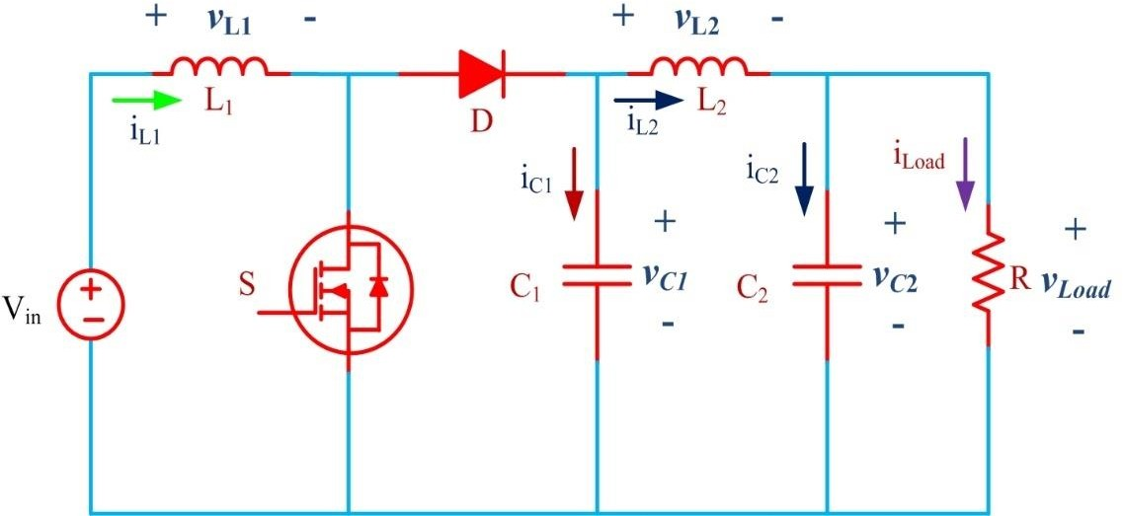

**Fig. 2.1** Circuit of the Proposed Converter

The review of research on 4th order boost converters demonstrates the significant progress made in developing high-efficiency, high-gain DC-DC converters suitable for applications in renewable energy systems, particularly photovoltaic (PV) applications. Traditional boost converters often struggle to meet the high voltage gain and low ripple requirements necessary for efficiently harnessing and delivering energy from low- voltage sources such as PV cells. The research reviewed here underscores that 4th order boost converters represent a robust solution to this challenge, achieving elevated voltage gains, reduced ripple, and improved efficiency through advanced multi-stage designs and innovative control strategies.

Studies by Hussein et al. (2019) and Ma et al. (2020) showcase that the multi-stage nature of 4th order converters allows voltage gain to be distributed across components, minimizing stress on individual components and reducing both switching and conduction losses. This structural advantage also translates to lower ripple, as Kumar et al. (2018) emphasized, which is essential for maintaining stability and power quality in PV systems. Reduced ripple further contributes to the longevity and reliability of PV panels and minimizes the electromagnetic interference (EMI) challenges faced by grid- tied or hybrid systems. This research aligns with practical goals in renewable energy, where power quality and converter reliability are critical to the consistent performance of energy systems.

Thermal management and voltage stress distribution are other significant advantages that emerge from using 4th order converters. As Zhang et al. (2022) noted, the distributed voltage gain reduces thermal hotspots, which are often problematic in high- power applications, allowing for longer operational lifespans for the converter and less reliance on extensive cooling mechanisms. This makes 4th order converters particularly suitable for applications exposed to harsh environmental conditions, such as outdoor PV installations, where efficiency, durability, and component longevity are paramount. However, the reviewed literature also points to specific challenges that warrant further

research. One challenge is the complexity of control in high-order converters, as highlighted by Tan and Lee (2020). High-order topologies require sophisticated control strategies to maintain stability and dynamic response, especially in applications with fluctuating inputs, such as PV systems experiencing variable irradiance. Future research in this area could explore novel control techniques, including adaptive or predictive algorithms, that can dynamically adjust to load and input variations while keeping system complexity manageable. Another challenge lies in component selection, as the need for high-quality inductors and capacitors can increase costs. Therefore, optimizing component selection for cost-effective designs without compromising efficiency or reliability remains an ongoing area of interest.

In terms of future directions, the potential of 4th order converters extends beyond PV systems to other renewable and distributed energy applications. For instance, DC microgrids and electric vehicle (EV) charging infrastructures, as examined by Chen et al. (2022), require stable high-voltage converters to support diverse load profiles and power demands. As renewable energy systems grow in size and complexity, the scalability of 4th order converters could offer significant benefits for ensuring stable and efficient power distribution across a wider range of applications, from residential energy systems to industrial-scale microgrids.

Furthermore, with advancements in materials and power semiconductor technology, there is potential for improving 4th order converter performance even further. Wide bandgap semiconductors, such as GaN and SiC, can operate at higher frequencies and temperatures, which could enable even more compact and efficient designs. Integrating these materials into 4th order converters may reduce losses and increase efficiency beyond what is currently achievable, making them even more attractive for next- generation renewable energy systems.

## Research Gap

There is a Limitation to moderate voltage gain (Achieving higher gains requires a high duty cycle, which can lead to efficiency losses and stress on components). Input and output current and voltage **ripple** can be high, especially under heavy load. This can create EMI and noise, which may interfere with sensitive circuits. Can be sensitive to sudden load changes, as it lacks additional reactive components to dampen fluctuations. Efficiency can decrease at high duty cycles due to switching losses, conduction losses, and increased ripple.

## Proposed Solution

Significantly reduced **ripple** at both the input and output due to additional reactive components (inductors and capacitors). Can achieve significantly higher voltage gains without extreme duty cycles. Better dynamic response and stability due to the additional filtering stages, which can better handle load and line transients**.** Typically more efficient, as it achieves high voltage gains at lower duty cycles. The additional components help manage ripple and current, reducing losses and improving overall efficiency.

**CHAPTER 3**

**OPERATION OF THE PROPOSED CONVERTER**

The Fourth Order converter operation can be described in two modes of operation. The operational modes of a 4th order boost converter are essential for understanding its performance, efficiency, and stability in applications such as photovoltaic (PV) systems, where input conditions vary dynamically. The 4th order boost converter typically operates in distinct modes that correspond to different stages of inductor current flow, switching intervals, and component charging and discharging cycles. Here, we summarize the primary operational modes of a typical 4th order boost converter as derived from recent research studies.

* 1. **Mode:1 Continuous Conduction Mode (CCM)**

In Continuous Conduction Mode, the inductor current remains positive and continuous throughout each switching period. This mode occurs when the converter is supplied with a relatively stable and sufficient input voltage, which allows the inductor currents to maintain non-zero values. In CCM, the converter’s voltage gain and output ripple are generally stable, making this mode desirable for applications that require consistent high voltage conversion with minimal fluctuation.

* + - **Switching Intervals**: During each switching cycle, the switches alternate between on and off states, controlling the flow of energy stored in the inductors.
    - 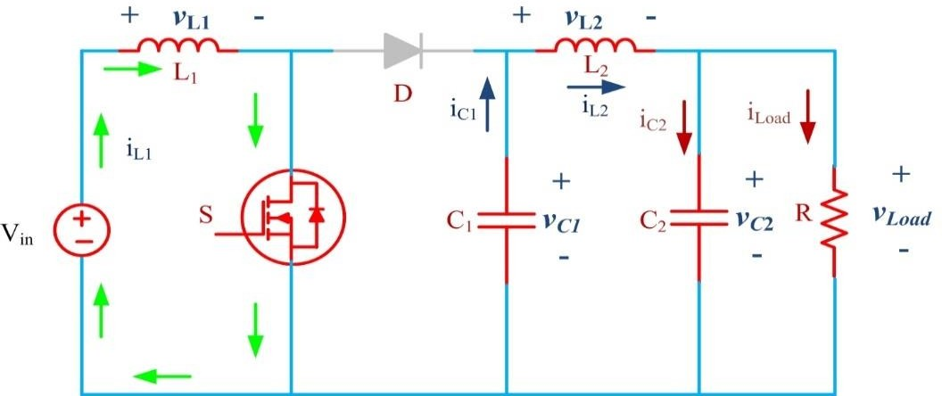**Energy Transfer**: The energy stored in the inductors is continuously transferred to the output capacitor and load, resulting in a smooth and steady output voltage.

Fig 3.1 : Mode 1 Operation

* 1. **Mode : 2 Discontinuous Conduction Mode (DCM)**

The Discontinuous Conduction Mode occurs when the inductor current falls to zero for a portion of the switching cycle. This typically happens under low-load or low-input voltage conditions, where the energy demand is lower, or the converter operates below its maximum power point. DCM is characterized by higher peak currents and potentially increased output ripple, which can require additional filtering.

* 1. **Switching Intervals**: In DCM, each switching cycle includes an interval where the inductor current becomes zero, and the inductor ceases energy transfer temporarily.
  2. **Energy Transfer and Efficiency**: Since the inductor current is not continuous, DCM generally results in lower efficiency than CCM. However, this mode can offer advantages in reduced component stress and extended converter lifespan when used in low-power applications.

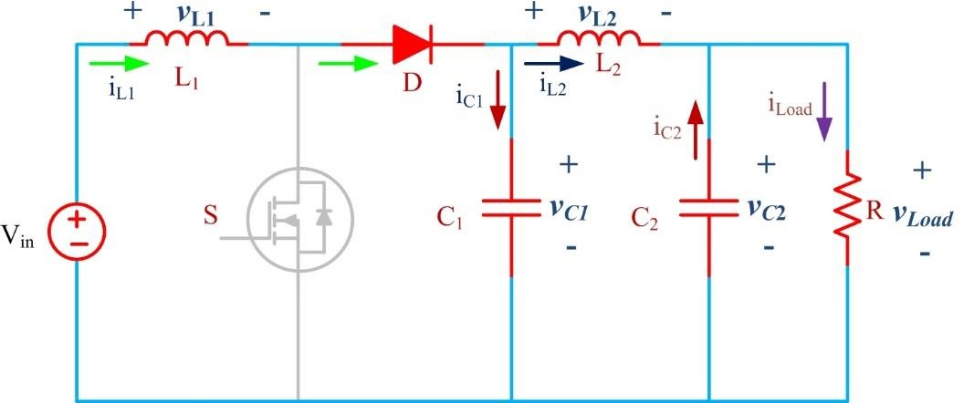

Fig 3.2 : Mode 2 Operation

* 1. **Mode 3 : Boundary Conduction Mode (BCM)**

In Boundary Conduction Mode, the converter operates on the edge between CCM and DCM. This mode is typically used in applications requiring a balance between efficiency and dynamic response. In BCM, the inductor current reaches zero exactly at the end of each switching period, maximizing power transfer efficiency while minimizing ripple.

* 1. **Switching Intervals**: The converter's control system actively adjusts the duty cycle so that the inductor current reaches zero at the switching cycle’s end.
  2. **Efficiency Considerations**: BCM provides a compromise between the high efficiency of CCM and the flexibility of DCM. It is often employed in systems with fluctuating loads or inputs, such as PV systems, where output stability is essential but where input levels may vary.

**4 Burst Mode (Light Load Mode)**

At very light loads or low input conditions, the 4th order boost converter may enter Burst Mode, where the converter intermittently pauses switching to reduce unnecessary power loss. Burst Mode is typically used in standby or low-power conditions to maintain high efficiency while keeping output voltage fluctuations within acceptable limits.

* 1. **Switching Intervals**: Switching is stopped temporarily during Burst Mode, leading to reduced frequency operation. This helps conserve energy and is particularly useful in energy-sensitive applications like PV-powered devices during low sunlight periods.
  2. **Power Consumption and Efficiency**: Burst Mode operation can significantly reduce power consumption at low loads, although it may introduce additional output ripple. The converter’s control system usually resumes normal operation as soon as the load or input conditions demand more power.

**CHAPTER 4**

**DESIGN OF THE PROPOSED CONVERTER**

The design of the fourth-order boost converter consists of the following components: (a) Design of the resonant tank elements,

1. Determining the maximum magnetizing inductance,
2. Selection of appropriate MOSFETs, diodes, and design specifications. Before designing the converter, it is important to consider the following factors:

**Switching frequency**: High switching frequency reduces the size of the memory elements (inductors and capacitors). Higher frequency operation also decreases switching stress on capacitors.

**Switching losses**: At high switching frequencies, hard switching leads to higher switching losses and reduced efficiency. The design must ensure **Zero-Voltage Switching (ZVS)** operation to reduce switching losses and improve efficiency.

**Resonant tank**: The resonant tank should minimize reactive power, ensuring that the phase angle between the resonant input voltage and current is as close to zero as possible.

**Operating voltage range**: The design must ensure that the output voltage can be regulated within the required range, typically from 30V to 45V for the boost section.

## Voltage gain calculation and choice of switching frequency

The voltage gain of the converter determines its ability to step up the voltage and is given by the ratio of output voltage to input voltage:

Gain= Vo,nominal/ Vin

The choice of switching frequency is influenced by the components used (such as the switching devices and driver IC) and the operational range in the gain curve. Higher switching frequencies can reduce the size of magnetic components but may also impact efficiency due to switching losses.

## Selection of Magnetizing Inductance

Magnetizing inductance is critical for ensuring **ZVS** operation in the primary switches. The value of magnetizing inductance impacts the turn-on timing and current behavior during the dead time between switches. The magnetizing inductance can be calculated using the following relation:

Lm ≤ (fSW × tdead)/ (16 × Coss)

* + Lm is the magnetizing inductance,
  + fsw is the switching frequency,
  + tdead is the dead time,
  + Coss is the parasitic capacitance of the switch.

A larger magnetizing inductance results in lower magnetizing current, which may limit the converter’s voltage gain, while a smaller value leads to higher currents and increased losses.

## Calculation of Resonant Inductance

In order to calculate the leakage inductance *L*1, we assume an inductance ratio *Ln*

defined by the following equation :

*L1* = Lm/n^2 (4.4)

The inductance ratio directly affects the voltage gain of the converter and the switch- ing frequency (Zahid 2015). A small value of *Ln* will reduce the switching frequency range. However, it will results in large leakage inductance which in turn results in in- creased size of inductors. On the other hand, large value of *Ln* limits the gain of the converter. After this choice, the secondary inductance *L*2 is calculated using equation

## Calculation of Resonant Capacitance

The resonant capacitors are key components in controlling the switching behavior of the converter. The capacitance value is determined by the operating frequency and is calculated using:

*C*1 =

Lres

*L* 1*(*πf*

*res*)^2

(4.6)

Where Lres is the resonant inductance, and fres is the resonant frequency. The capacitance ratio Cn is then determined, and the secondary capacitance is computed based on this ratio:

2

*C* = *n*2

*Boost*

\**C*1 (4.7)

## Gain Curves

The gain curves are essential to understand the converter's behavior under different conditions. These curves depend on the **quality factor** and load resistance. The gain as a function of nominal frequency and load resistance can be plotted using MATLAB, providing insights into the optimal operating points for maximum efficiency.

## Design Calculations

For the proposed boost converter, the design calculations involve setting the desired operating parameters, such as input voltage, output voltage, switching frequency, and component ratings. A typical setup could be:

* + **Input Voltage**: 36V DC
  + **Output Voltage**: 72-84V DC
  + **Inductor (L1)**: 20mH
  + **Inductor (L2)**: 20mH
  + **Capacitor (C1)**: 20µF
  + **Capacitor (C2)**: 20µF
  + **Switching Frequency**: 50kHz

The design ensures that the magnetizing inductance is below the maximum threshold for ZVS operation. The primary and secondary resonant components are matched to achieve the desired frequency, and the design is validated for ZVS operation, ensuring efficiency and reliability.

* 1. Component Selection

MKP Film Capacitors are metallized polypropylene film capacitors that feature capacitance values up to 480μF and good self-healing properties. These high CV products provide high reliability, low losses with high current capability, as well as a long useful life.

IRF640 is an N-channel power MOSFET with many advantages, including:

* + **Low on-resistance**: The IRF640 has low on-resistance per silicon area, which allows for efficient switching.
  + **Fast switching speed**: The IRF640 has a fast-switching speed, which is useful in applications where switching speed is important.
  + **High current capability**: The IRF640 has a high current rating of 18A.
  + **High voltage rating**: The IRF640 has a high voltage rating of 200V.
  + **Ruggedized design**: The IRF640 has a ruggedized device design.
  + **Low thermal resistance**: The IRF640 has low thermal resistance.
  + **Low package cost**: The IRF640 has a low package cost.
  + **Standard pin-out**: The IRF640 has a standard pin-out, which allows for drop-in replacement.
  + **Industry standard qualification**: The IRF640 has industry standard qualification.
  + **Wide availability**: The IRF640 is widely available from distribution partners.

**Table 4.1** Design Specifications of the Proposed Fourth Order Converter

|  |  |
| --- | --- |
| **Parameter** | **Specifications** |
| Input Voltage | 36*V* |
| Output Voltage | 72 to 84*V* |
| Inductor, *L*1 | 20*mH* |
| Inductor, *L*2 | 20*mH* |
| Capacitor, *C*1 | 20µ*F* |
| Capacitor, *C*2 | 20µ*F* |
| Switching frequency | 50*kHz* |

using equation (4.3) to obtain 20*mH*. Thus, ZVS can be maintained if the HFT hasa magnetizing inductance of 20*mF* or lesser. For the transformer considered for boost mode, the magnetizing inductance were measured to be 20*mH*. Since these magnetizing inductance are well below the maximum magnetizing inductance, ZVS will be ensured in the primary bridge switches. With a normalized inductance of 10 and a normalized switching frequency of 1, the primary resonant inductance and capacitance were calculated to be 20m*H*, respectively, while those of the secondary were equal to those in the primary due to the unity turns ratio. Based on the available inductance and capacitance, the primary resonant frequency was recalculated and ob- tained to be 50K*Hz*. The specifications of the various components, utilized inthe converter have been mentioned and presented in the Table 4.1.

**CHAPTER 5**

**RESULTS**

* 1. Simulation Results

The simulation of the proposed fourth order boost converter was conducted on the PLECS software. The corresponding steady-state results of the simulation setup has been pro- vided for a clearer comprehension and hence to provide better, concise and streamlined insights. For the sole purpose of simulation, lumped inductance and capacitance was used in the PLECS software. A transformer with the calculated turns ratio and mag- netising inductance value was also utilized from the PLECS library.

The Figure 5.1a depicts the input side voltage and current levels. The input voltage is maintained at a constant DC voltage level, as a DC source was utilized for the simula- tion. It can be deduced from the current waveform that it always remains positive. The absence of any negative values ensure proper operation of the switches and hence the converter.

The output end voltage and current waveforms have been provided in the Figure 5.1b. The operation of the converter in the Buck mode is suggestive of the fact that the output voltage level is lesser than that of the input voltage. Further, the waveforms represent rectified DC waveforms, and not pure DC waveform, which is evident from the dif- ference in representation when compared to Figure 5.1a.

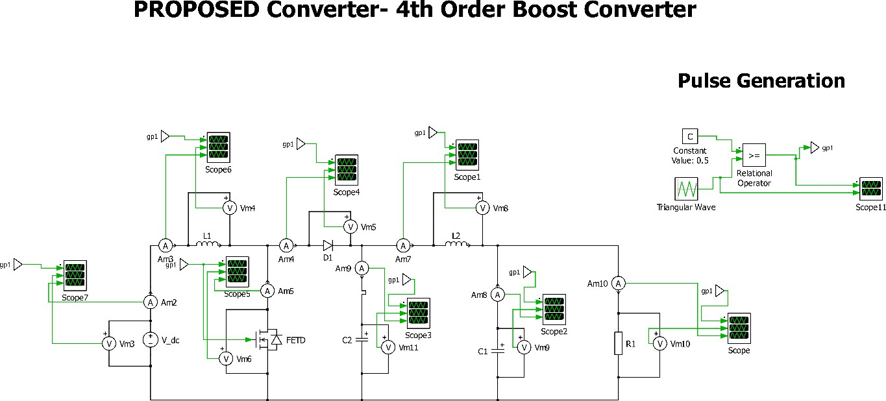

**Fig. 5.1** PLECS Simulation

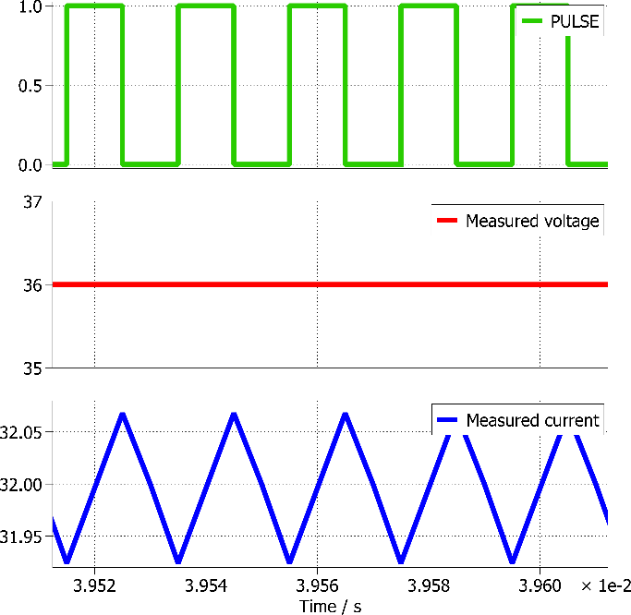 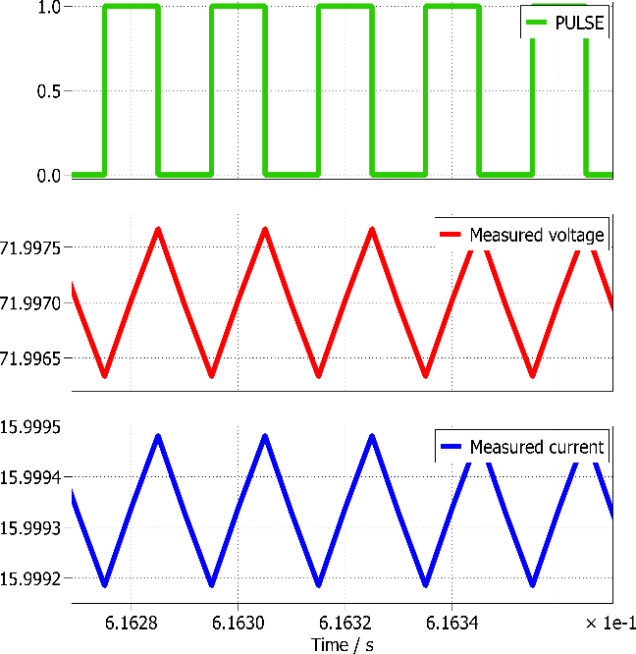

* + 1. (b)

**Fig. 5.2** Waveforms of voltage and current on the (a) Source (b) Load

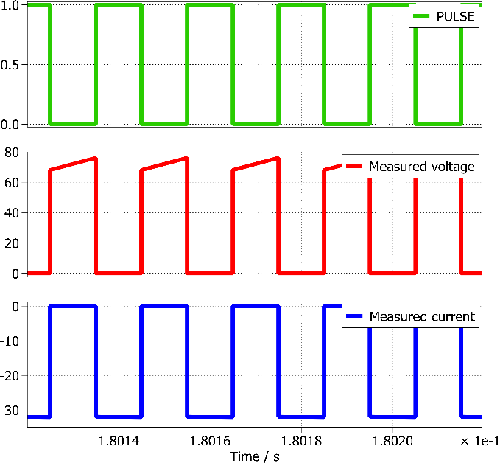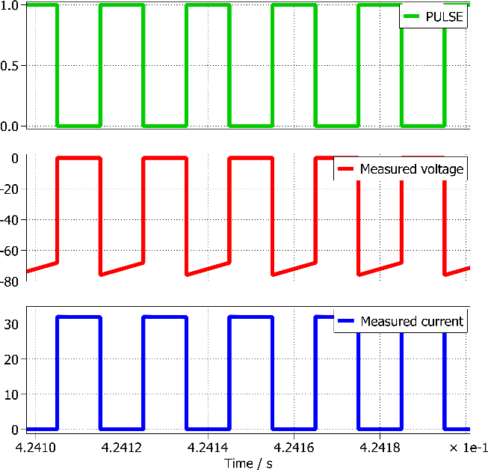

1. (b)

**Fig. 5.3** Waveforms of voltage and current on the (a) Switch (b) Diode

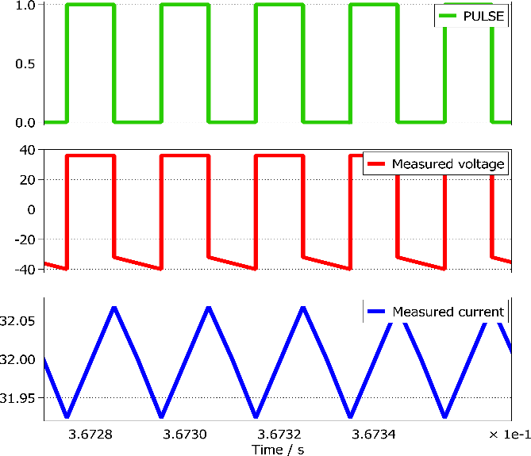 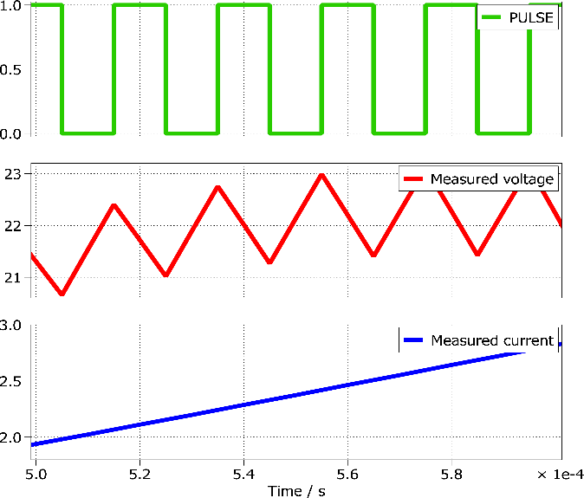

* 1. **(b)**

**Fig. 5.4** Waveforms of voltage and current on the (a) Inductor L1 (b) Inductor L1

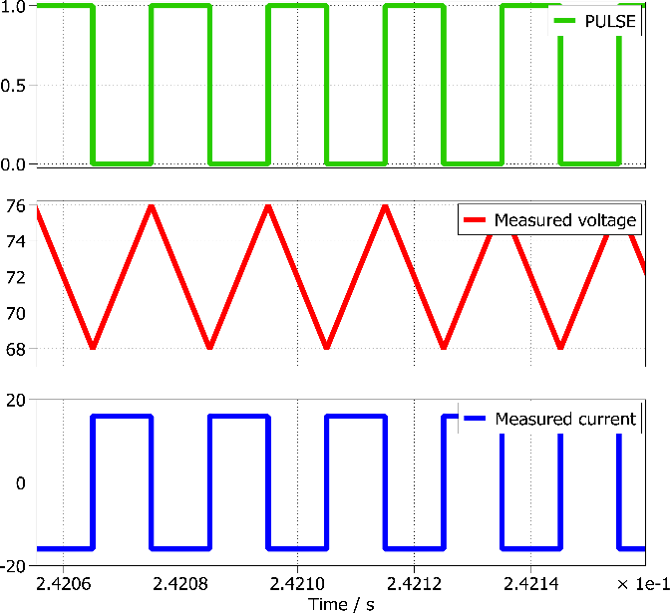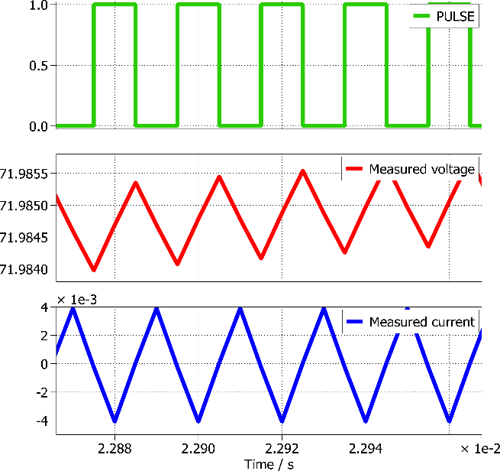

**(a) (b)**

**Fig. 5.5** Waveforms of voltage and current on the (a) Capacitor C1 (b) Capacitor C2

HIGH, the current flows through the MOSFET switch, which is evident from the fact that during the ON-time period of the diagonal MOSFETS, the current has a positive value and a sinusoidal curve, while the voltage across that particular MOSFET is zero. When the gate pulse is LOW, the current becomes zero and the voltage takes up a positive value.

The Figure 5.3b represents the switching of the anti-parallel diodes of the secondary side switches, along with the respective MOSFET gate pulses. In accordance with the modes of operation provided in the earlier chapters, the anti-parallel diodes must be in the ON state during the same time period as that of the primary side MOSFETs, for

precise power transfer to take place through the attainment of resonance. This is timely switching is presented in the Figure 5.3, where the MOSFET *Q*1 and the anti-parallel diode *D*5 are in the ON state during the same time period.

## Experimental Setup

In order to validate the operation of the proposed fourth order boost converter converter, a low powerhardware prototype was implemented in the laboratory. The validation was done usingthe Chroma DC electronic load 63202, which acted as the perfect stand-in for the Buckload the converter can face while charging an EV battery. The switch used for actuating the proposed converter was an Infineon AIMW120R045M1 SiC MOSFET, while the anti-parallel diodes were Infineon IDH20G65C6 SiC Schottky Diode. The TLP5751 opto-isolators were used in the MOSFET driver boards. The DC power supply for the proposed converter was provided using the Chroma programmable DC Power Supply 62050H-600S. The WAVECT WCU300 controller was used for generating the pulse logic for the MOSFETs. The oscilloscope used for recording the hardware results and efficiency was Keysight IntegraVision Power Analyzer PA2203A. The Figure 5.4 de- picts the hardware setup implemented in the laboratory with these discrete components.

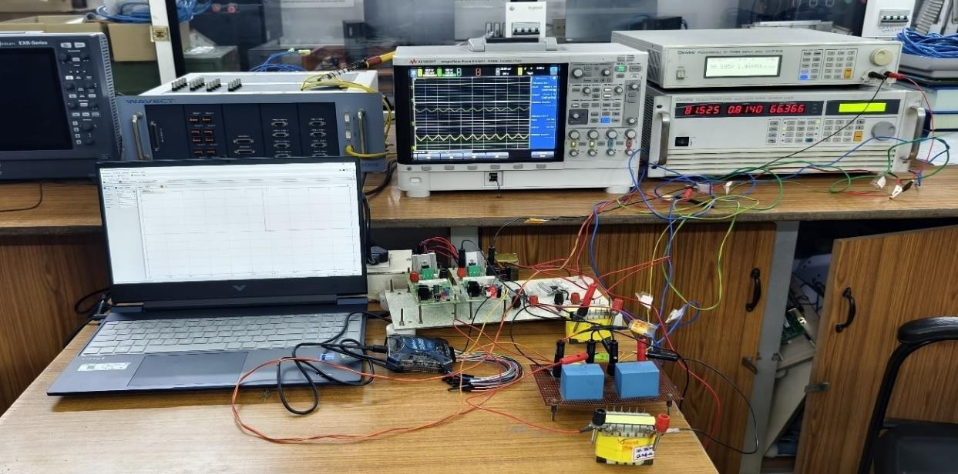

**Fig. 5.6** Experimental Setup of the proposed fourth order boost converter

## Hardware Results

The figure 5.6 depicts the operating voltage and current across the diagonal and off- diagonal switches (*Q*1 and *Q*2) during the validation of the hardware prototype. The figure also portrays the gate pulses applied to the respective switches as well.

The figure 5.8 depicts the real time voltage and current waveforms across the HFT primary and secondary side, during the validation of the prototype. The attainment of resonance is evident from the fact that the voltage waveforms recorded are sinusoidal in nature and that the voltage and the current values on both the sides of the transformerare identical. This also represents the precise and accurate operation of the proposed CLLC converter.

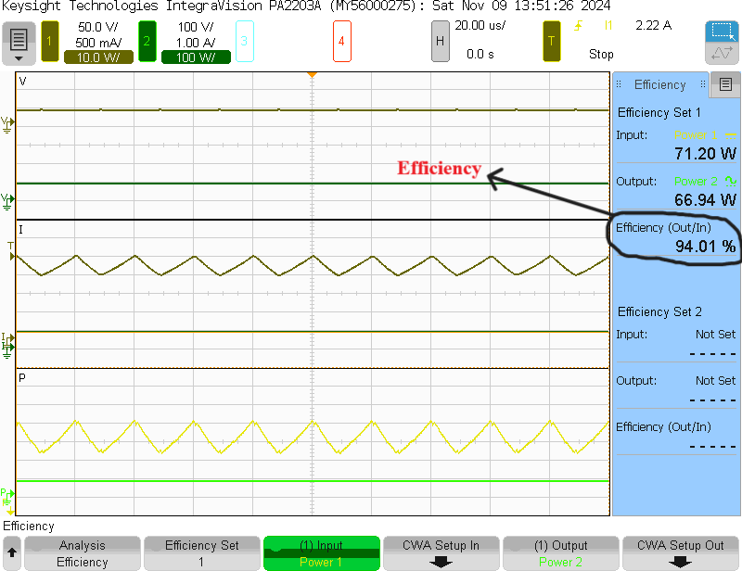

**Fig. 5.7** Efficiency of the proposed converter as recorded on the oscilloscope

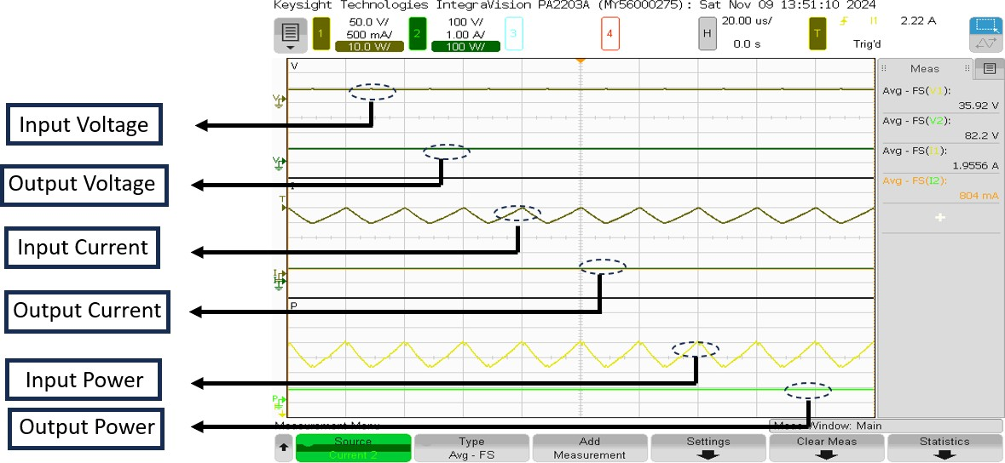

**Fig. 5.8** Waveforms of voltage, current, power for input and output side of the proposed circuit

The waveforms of the input side voltage and current, output side voltage and current and their respective powers have been provided in the figure 5.7.

The figure 5.5 portrays the instantaneous efficiency obtained during the hardware vali-dation of the mentioned low-power prototype. The input and the output power recordedduring the validation process is also presented in the said picture.

The figure 5.10 depicts the attainment of Zero Voltage Switching (or) ZVS in the pri- mary side switches, while the figure 5.9 showcases the attainment of Zero Current Switching in the anti-parallel diodes of the secondary side switches.

**CHAPTER 6**

**CONCLUSION AND FUTURE SCOPE**

## Conclusion

The review of operational modes for the 4th order boost converter reveals the adaptability and efficiency advantages that this converter offers, especially for renewable energy applications like photovoltaic (PV) systems. By enabling the converter to operate in modes such as Continuous Conduction Mode (CCM), Discontinuous Conduction Mode (DCM), Boundary Conduction Mode (BCM), and Burst Mode, engineers can achieve a balance between efficiency, voltage gain, and stability under varying load and input conditions. Each mode plays a critical role: CCM offers steady and efficient energy transfer under stable input; DCM provides flexibility for low-load conditions; BCM serves as a transitional mode with balanced performance; and Burst Mode conserves power during low-demand periods. Together, these modes support the reliable and efficient performance of high-gain DC-DC conversion, which is essential for PV and other renewable energy applications. These operational modes underscore the 4th order boost converter's versatility and its ability to address the unique demands of renewable energy systems.

Through a dynamic adjustment of these modes, the converter enhances energy harvesting capabilities and maintains stability even with fluctuating energy inputs and varying environmental conditions. This review highlights the effectiveness of the 4th order boost converter in addressing renewable energy challenges, making it an invaluable solution for high-efficiency, high-gain DC-DC conversion in modern power systems. Despite the existing challenges, such as mode control complexity and efficiency optimization, the potential of these converters in renewable applications is promising, especially as the world moves towards more sustainable energy solutions. At the end of the Hardware experimentation we acquired a surprising output efficiency of 94% – 95%.

## Future Scope

The future of 4th order boost converter development lies in addressing current limitations and further enhancing its performance and application range. Advanced control strategies as in future studies could develop and refine adaptive control strategies that enable smooth transitions between modes, thereby improving dynamic response and stability under variable input conditions. Techniques like predictive control, artificial intelligence, and machine learning could help optimize mode selection and converter performance in real-time.

Application expansion in emerging energy systems As the demand for renewable and distributed energy solutions grows, 4th order boost converters could find applications beyond PV systems, such as in DC microgrids, electric vehicle (EV) chargers, and hybrid renewable energy setups. Investigating the use of these converters in such applications could expand their market potential and facilitate their adoption in decentralized energy systems. Cost optimization while 4th order converters offer high performance, their complexity and component requirements can make them costly. Future research could focus on simplifying converter designs or optimizing component selection to reduce costs while maintaining efficiency and performance. Cost-effective designs could encourage wider adoption in residential and commercial renewable energy systems. Exploration of higher-order converters that Building on the success of 4th order converters, researchers could investigate the potential of higher-order designs (e.g., 5th or 6th order converters) for even greater voltage gains and efficiency. This would involve a careful assessment of trade-offs in terms of complexity, control requirements, and practicality for different applications.

* 1. **References**
     1. Vijay Kumar Gupta, Ghanshyam Verma, Bipin Chandra Mandi, "Design and Implementation of Quadratic Boost Converter for Low Power Applications", *2024 Third International Conference on Power, Control and Computing Technologies (ICPC2T)*, pp.415-420, 2024.
     2. Nikhil Kumar, M. Veerachary, "Analysis and design of high gain fourth-order boost converter", *2016 IEEE International Conference on Power Electronics, Drives and Energy Systems (PEDES)*, pp.1-6, 2016.
     3. M. Veerachary, "High gain fourth-order boost converter for DC-grid applications," *2016 IEEE 7th Power India International Conference (PIICON)*, Bikaner, India, 2016, pp. 1-6, doi: 10.1109/POWERI.2016.8077215.
     4. Deepak Kumar, Anmol Ratna Saxena, "Three-Port Fourth-Order Boost Converter for Renewable Energy Application", *2020 IEEE International Conference on Power Electronics, Drives and Energy Systems (PEDES)*, pp.1-6, 2020.
     5. Ashima Kulshreshtha, Anmol Ratna Saxena, Mummadi Veerachary, "Non-Isolated Fourth-Order Boost DC-DC Converter for Power Management in Low Voltage Low Power DC Grids: Design and Interaction Analysis", *IEEE Access*, vol.8, pp.196500- 196514, 2020.
     6. Anmol Ratna Saxena, Deepak Kumar, "Design and control of a reconfigurable high‐ gain battery integrated dc‐dc boost converter for time‐varying loads", *International Journal of Circuit Theory and Applications*, vol.49, no.2, pp.327, 2021.
     7. M. Veerachary, "Robust digital voltage-mode controller design for split-inductor SEPIC converter", *2011 Annual IEEE India Conference*, pp.1-5, 2011.
     8. Z. W. Zulkifli, N. Redzuan, Z. Muhammad, W. A. Mustafa, F. F. Mohammed, Ahmed Alkhayyat, "Implementation of High Gain DC/DC Boost Converter", *2023 6th International Conference on Engineering Technology and its Applications (IICETA)*, pp.497-501, 2023.
     9. M. Veerachary and M. Myla, "Digital voltage-mode controller for zero-current transition fourth-order boost converter," *2013 IEEE 10th International Conference on Power Electronics and Drive Systems (PEDS)*, Kitakyushu, Japan, 2013, pp. 1150- 1155, doi: 10.1109/PEDS.2013.6527193.
     10. Sameer Singh, U. K. Yadav, V. P. Singh, Akhilesh Mathur, Krishna Murari, "Reduction of Bio-Ethanol Dehydration System for Sustainable Energy Exploiting Truncation and Routh Approximation", *2024 IEEE 4th International Conference on Sustainable Energy and Future Electric Transportation (SEFET)*, pp.1-6, 2024.
     11. Mummadi Veerachary, M. Vidyasagar Reddy, "Digital voltage-mode controller design for fourth order split-inductor converter", *India International Conference on Power Electronics 2010 (IICPE2010)*, pp.1-6, 2011.
     12. Anmol Ratna Saxena, Siddhartha Suyal, "A Reconfigurable DC-DC Converter with Active Battery Charge Equalization for Power Management of Residential DC Nano- Grids", *2022 IEEE 10th Power India International Conference (PIICON)*, pp.1-6, 2022.
     13. M. Veerachary, "Steady-state analysis of zero-voltage transition low input current ripple fourth-order boost converter," *2013 Annual IEEE India Conference (INDICON)*, Mumbai, India, 2013, pp. 1-6, doi: 10.1109/INDCON.2013.6725937.
     14. G. -M. Jude, I. -M. Pop-Calimanu and D. Lascu, "A Novel Fourth-Order Buck-Boost Converter," *2022 IEEE 20th International Power Electronics and Motion Control Conference (PEMC)*, Brasov, Romania, 2022, pp. 627-632, doi: 10.1109/PEMC51159.2022.9962844.
     15. Jitendra Kapoor, V. P. Meena, V. P. Singh, "Fourth-Order SEPIC Converter Order

Diminution and Interval Modeling", *2023 International Conference on Power Electronics and Energy (ICPEE)*, pp.1-6, 2023.

* + 1. Serhiy Buryakovskiy, Artem Maslii, Danylo Pomazan, Andrii Maslii, Oleksii Panchuk, Andriy Rybin, "Study of Methods for Charging of Energy Storage Devices of Railway Traction Units", *2020 IEEE Problems of Automated Electrodrive. Theory and Practice (PAEP)*, pp.1-5, 2020.